Prismika Gurung, Nauman and Ahmad
Group 12
Stock Segmentation and Portfolio Analysis of the S&P 500 Using Clustering Techniques

This report presents an analysis of S&P 500 stocks using clustering techniques to support investment decision-making. The S&P 500 represents 500 large-cap companies across multiple sectors and provides a comprehensive dataset for analysing stock performance and risk.
The aim of this study is to segment stocks based on three key financial metrics: Daily Return, Beta and Annual Volatility. These metrics provide insights into stock performance, market sensitivity and risk. Clustering techniques such as Agglomerative Clustering and K-Means are used to group stocks with similar characteristics. The results of this analysis are used to support portfolio diversification strategies and to demonstrate how data-driven approaches can help investors align their portfolio with different risk tolerances. The report also explores how Customer Relationship Management (CRM) tools can support sustainability in FinTech.
The analysis was based on S&P 500 stock data collected using Python libraries such as Pandas and yfinance. Three key financial metrics were calculated: Daily Return, Beta and Annual Volatility. These metrics were used to represent stock performance and risk. Clustering techniques, including K-means, were applied to group stocks into categories based on similar behaviour. The results of these clusters were then analysed to support investment decision-making and portfolio diversification.

3.1 Dimensions and Metrics for Investment Analysis
The design of a data mart for analysing the S&P 500 should focus on key dimensions and metrics that support investment analysis and decision-making. The main dimensions include Time, Stock, Sector, Industry, Location and Cluster Segment. The Time dimension allows analysis across different trading periods, while the Stock dimension identifies each company using its ticker symbol. Sector and Industry allow comparison of stock behaviour across different parts of the economy, while Location provides geographical insight into company headquarters. The key metrics used are Daily Return, Beta and Annual Volatility, as shown in Figure 1. Daily Return measures short-term performance, Beta measures sensitivity to market movements, and Annual Volatility measures overall risk.
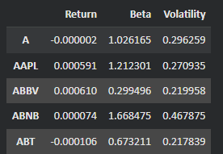

Figure 1: Sample of Calculated Financial Metrics (Daily Return, Beta and Annual Volatility)

Using Python, stocks were segmented into clusters using K-Means clustering, as shown in Figure 2. These clusters represent business value segments such as low-risk, medium-risk and high-risk stocks based on their financial behaviour. These segments were generated using Python-based clustering techniques, providing a data-driven approach to stock classification. These dimensions and metrics provide business value by allowing investors to compare stocks based on risk and return characteristics. This enables more effective portfolio diversification, as investors can select a mix of low-risk, medium-risk and high-risk stocks aligned with their risk tolerance and investment goals.

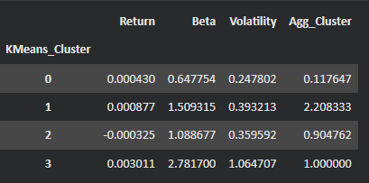

Figure 2: K-Means Cluster Summary Showing Stock Segmentation Based on Risk and Return

3.2 Review of Results

The clustering results provide valuable insights into stock behavior by grouping S&P 500 stocks based on similar risk and return characteristics. The analysis is based on three key financial metrics: Daily Return, Beta and Annual Volatility. These metrics are interrelated and together help investors understand both performance and risk.

Daily Return measures the short-term performance of a stock, indicating how much a stock’s price changes on average. However, higher returns are often associated with higher risk. This relationship is captured through Annual Volatility, which measures how much stock returns fluctuate over time. Stocks with high volatility experience larger price swings, making them riskier investments. Beta measures how sensitive a stock is to overall market movements. A beta greater than one indicates that the stock is more volatile than the market, while a beta less than one suggests lower sensitivity and more stable behavior.

These metrics are dependent on each other, as stocks with higher Beta tend to exhibit higher Annual Volatility and often higher Daily Returns. This relationship highlights the trade-off between risk and return, which is essential for investors when constructing a diversified portfolio.

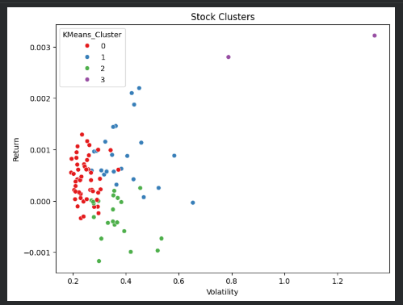

Figure 3: Stock Clusters Based on Return and Volatility Using K-Means Clustering

The visualisation of stock clusters in Figure 3 highlights how stocks are distributed based on their return and volatility characteristics. Distinct clusters can be observed, where some groups contain high-risk stocks with higher returns, while others consist of lower-risk, more stable stocks. These clusters represent distinct business value segments, allowing investors to clearly differentiate between low-risk, medium-risk and high-risk stocks.



Figure 4: Average Return, Beta and Volatility by Cluster

As shown in Figure 4, clusters with higher beta values tend to also have higher volatility, indicating higher-risk, high-return investment opportunities, while clusters with lower beta and volatility represent more stable investment options.

From an investment perspective, these clusters provide clear business value by supporting portfolio diversification. Investors can construct a balanced portfolio by selecting stocks from different clusters. For example, combining low-risk stocks with lower beta and volatility with higher-risk stocks can help achieve a balance between stability and growth. Relying only on high-risk stocks may lead to significant losses during market downturns, while focusing only on low-risk stocks may limit potential returns.

Overall, the clustering approach allows investors to better understand stock behavior and make more informed investment decisions by aligning their portfolios with their risk tolerance and financial goals.

3.3 CRM as a Driver for Sustainability in FinTech

Customer Relationship Management (CRM) systems play a key role in supporting sustainability within FinTech by enabling organisations to deliver more efficient, data-driven and responsible financial services. CRM tools collect, store and analyse customer data such as transaction history, investment preferences and interaction records. This allows financial institutions to better understand customer behavior and tailor services accordingly.

One of the main contributions of CRM to sustainability is improved efficiency. By using data analytics and automation, CRM systems reduce unnecessary communication and operational waste. For example, instead of sending generic marketing campaigns, FinTech companies can use customer segmentation to target specific groups with relevant financial products. This reduces digital waste and improves customer engagement.

CRM systems also support responsible financial decision-making. By analysing customer profiles, risk tolerance and past behaviour, firms can recommend appropriate financial products. This helps prevent customers from being exposed to unsuitable high-risk investments, contributing to ethical and sustainable financial practices. In this way, CRM aligns business objectives with customer wellbeing, which is an important aspect of sustainability in FinTech.

From a technical perspective, CRM platforms integrate data analytics tools and machine learning models to generate insights such as customer lifetime value, churn prediction and personalised recommendations. These capabilities enable firms to make more informed decisions while reducing inefficiencies. For example, predictive analytics can identify customers at risk of leaving, allowing companies to intervene early and maintain long-term relationships. This reduces resource waste associated with constantly acquiring new customers.

However, the use of CRM systems also presents challenges. The collection and processing of large volumes of customer data raises concerns about data privacy and security. FinTech companies must ensure compliance with regulations such as GDPR and implement strong data protection measures. This highlights the need for responsible data governance frameworks to ensure that sustainability efforts do not compromise customer trust. Additionally, there is a risk that excessive reliance on automated decision-making may lead to biased or unfair outcomes if algorithms are not properly monitored.

Despite these challenges, CRM systems provide significant opportunities for creating a more sustainable financial ecosystem. By improving efficiency, enabling personalised services and supporting responsible investment decisions, CRM tools help FinTech companies balance profitability with social and environmental responsibility.

In conclusion, CRM systems contribute to sustainability in FinTech by enhancing operational efficiency, supporting ethical financial practices and enabling long-term customer relationships. When implemented responsibly, these systems play a critical role in creating a more sustainable and customer-focused financial industry.

